Las Vegas Market July 31, 2012

LiveNation – Michael Grozier, EVP Clubs & Theaters

NMG – Bill Napier, Kim Napier & Ed Schneider

Michael is in the process of sourcing furnishings for Private Party and Dressing rooms for concert venues and clubs that LiveNation owns and manages. Currently there are at least 14 venues, with his priority being Phoenix and Atlanta.

The intent and purpose of visiting Market was to help us and Michael define his style sense and allow him to see what is available. He is looking for seating, modular and individual, décor and lighting.

Our first stop was at Broyhill, where we were joined again by Jeff Smith, Matt Sorenson, and Mark Wiltshire.

Mark was very interested in working with Michael for his projects, and suggested their in-house design team could work up some layouts and designs for his rooms.

Michael and I did a walk through with Jessica, and below is her follow up email.

Bill, Below is a summary of everything we discussed today while walking through the Broyhill showroom. I have also included pictures of the pieces that we looked at.

Performance leather – likes the look and feel, would like to explore options of performance leather and fabric combinations such as performance leather arms with fabric back and seat.

[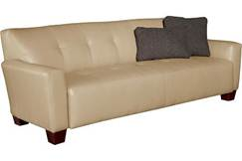](http://www.broyhillfurniture.com/Furniture/Photo-Zoom.aspx?PhotoID=106687)

[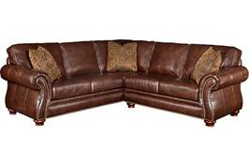](http://www.broyhillfurniture.com/Furniture/Photo-Zoom.aspx?PhotoID=106708)

Sectionals – likes the idea of multiple configurations, attached back pillows or tight backs, decrease the depth of the seats to make it easier to get up out of.

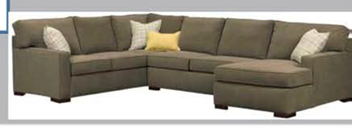

Liked the accent chairs and ottomans, but wants to increase the leg height.  Wants to explore possibilities of changing the shapes of the ottomans – width and length, possibly doing curved ottomans.

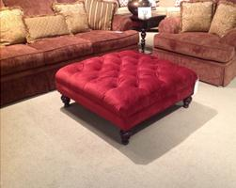

Liked the wide track arm on occasional chairs. perfect for people who will sit on the arms of chairs.

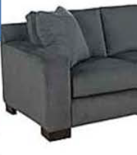   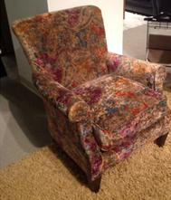

Thank you for allowing me to sit in on your meeting and show you around the Broyhill showroom. I have also forwarded this information onto Mark Wiltshire. He will be in touch with you to move onto the next steps!

Thanks again,

Jessica Wood

Broyhill Furniture

[(443) 856-5715](tel:%28443%29%20856-5715)

We then went to Best Furnishings where Tom Cigno who showed us some of their offerings. Michael was intrigued by their barrel style swivel chairs available in 4 colors. He also liked their quick turn around on manufacturing. He very much liked their Red Bonded leather sectional. Another great fit for them would be the Contemporary Chaise lounge that Best showed in their display window. And he was especially interested in the modular seating offered, The Halley Collection.

Our next stop was Marshfield Furniture. Michael liked their modular seating configurations, he also liked their unique ottomans. They also have many wedges and curved elements in their modular seating along with contrasting piping and stitching. Marshfield offers the option to pick your arm, pick your back, choose the leg, and choose the finish/fabric, offering endless combinations and options. The quality was very good, and we spoke with a rep that said that they have the ability to offer commercial fabrics and construction. They even feature a Hospitality category of furnishings.

[www.marshfieldfurniture.com](http://www.marshfieldfurniture.com)

Our next stop was a showroom with amazing décor - RCFurniture. I picked up a business card for Mark Williamson. RCFurniture is located in Los Angeles. He was very interested in their Aero Leather Swivel chairs. He especially liked their oversized mirrors which showed great detail and texture, and were room sized. We looked at one that he liked that was $3181. I don’t see mirrors on their website, but perhaps they can source these for Michael.

[www.rcfurniture.com](http://www.rcfurniture.com)

We also walked through Guildmaster,

<http://store.elegantfindsforyourhome.com/951003.html> .

Michael loved this bed and took pictures to send to his wife. We couldn’t find anyone to speak with, but they have a great website.

We walked into Elegant Lighting where Michael was attracted to the chandeliers. They offered many different colors and sizes. One was a black chandelier, and there were also some 14” chandeliers that would work well in dressing rooms. Michael said one of his current projects is a converted church and he was looking for possibly 2 matched chandeliers that he wanted to shine a black light on. The approximate size would be 42” high, with a diameter of 32 – 36”. They offered to send their catalog to Michael. [www.elegantlighting.com](http://www.elegantlighting.com).

Our next stop was Massoud. Michael saw an amazing funky sofa with leather and fabric.

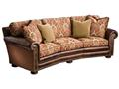

The owner/designer (?) Chuck Massoud said a quick hello, gave us his card and said he would follow up. They have a great website with all of their designs and fabrics shown, so it could be an excellent resource. Massoud is located in Dallas. [www.massoudfurniture.com](http://www.massoudfurniture.com)

In the back of the Massoud showroom, Michael discovered some excellent décor that he really liked. One thing was a figurine on a base that was approximately 32” tall and hung on a wall. He was also drawn to an angel wing. We then bumped into the designer of the piece who explained that he could create almost anything in any size Michael could want. These are designed and sculpted in resin. The company’s name is MAC Sculpture. The owner’s name was Nelson Sanabria. This should be an excellent resource for Michael.

<http://macsculpture.com/macCatalog/>